SAIMUN 2018

Approval Panel Introduction

1.0 SAIMUN 2018 IT Student Officers

If you are having an issue with the system you should contact a member of the IT Staff, the Student Officers in charge of SAIMUN 2017’s IT are listed below:

Head of IT | Aaron Speer
Deputy Head of IT | Oscar Doyle

The SAIMUN computerised system has been custom developed for the conference by Jack Harley, if you are interested in using the system for another conference please refer enquiries to Jack on jackpharley@gmail.com.

2.0 Introduction to Resolution Process

All resolutions at SAIMUN must go through a number of stages before they are debated in committee, these stages can be briefly summarised as follows:

- Resolution is submitted by a delegate through the computerised system

- The system automatically checks that:

  - No more than two co-submitters on the resolution are from the same school

  - The number of co-submitters meets the minimum number required by the committee (12 for most committees, 0 for Security Council)

- The resolution now must be reviewed by the Cosubmitter Validation Panel, SAIMUN staff will cross-check the co-submitters selected on the system with the signatures on the associated signature sheet and ensure they are all present and will perform basic checks for forgery.

- The resolution now goes to the Approval Panel, the approval panel member who processes

  - resolution must:

  - Check for spelling/grammatical/formatting mistakes and correct them

  - Check to ensure no invalid/disallowed clause openings are in the resolution (e.g. Security Council phrases in a non-Security Council resolution)

  - Select whether to approve or reject the resolution, if rejecting, a reason must be entered which will be publicly viewable

- The resolution is passed to the Secretariat, the Secretariat at SAIMUN consists of the Senior Student Officers (Secretary General, Deputy Secretary General) and the SAIMUN Director, the Secretariat selects the resolutions it wishes to be debated and rejects the remainder. A rejection of a resolution by the Secretariat does not indicate that it had any particular issues or that it was a poor resolution, it simply means that from the pool of resolutions on that topic, the Secretariat deemed other resolutions to be better for debate.

- The selected resolutions are printed throughout the duration of the conference by the Admin team and delivered to the committee rooms for debate. Please note that chairs have no insight into the order of debate, resolutions will be delivered at the Secretariats’ discretion.

3.0 The Approval Panel

This document will focus on stage #4, the Approval Panel.

Each member of the approval panel will receive a username and password to the computerised system. They will be listed on a sheet of paper on the wall of the Approval Panel room.
It is vital that you use only your username and password, and that you logout when finished using the system. You must not disclose your credentials to anyone, if a student or other unauthorised person is found to have obtained login details for an Approval Panel member the account in question will be deactivated and only the SAIMUN director (William Hehir) may authorise reactivation of the account.

3.1 Logging In:

The SAIMUN system can be accessed at http://system.saimun.ie at any time whilst connected to the SAIMUN internal network.
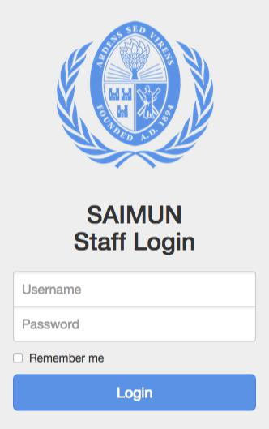
To login to the SAIMUN system, click on the Staff Login button at the top right of the site and enter your username and password, then click Login.

If your credentials do not work or you cannot find them please ask a member of the IT Staff for assistance, we can change your password or create you an account in the case that you do not have one.

3.2 Approval Panel Overview/Resolution List:
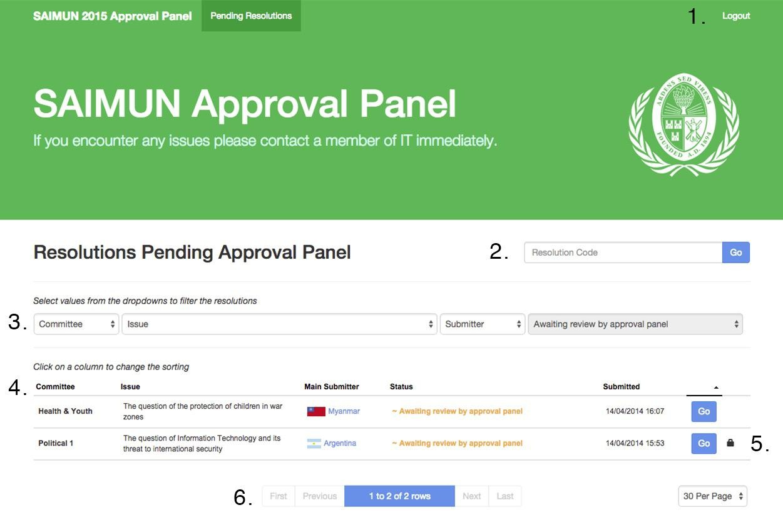
- Logout Button

- Go directly to a resolution if you know its code

- Filter resolutions by committee/issue/submitter

- Resolution list

- The padlock symbol indicates that someone has locked this resolution and is working on it

- Page controls for when there is more than one page of resolutions

3.3 Processing a Resolution

To begin working on a resolution simply press the Go button beside it, and you will be brought to a page showing details for the resolution, similar to that below:
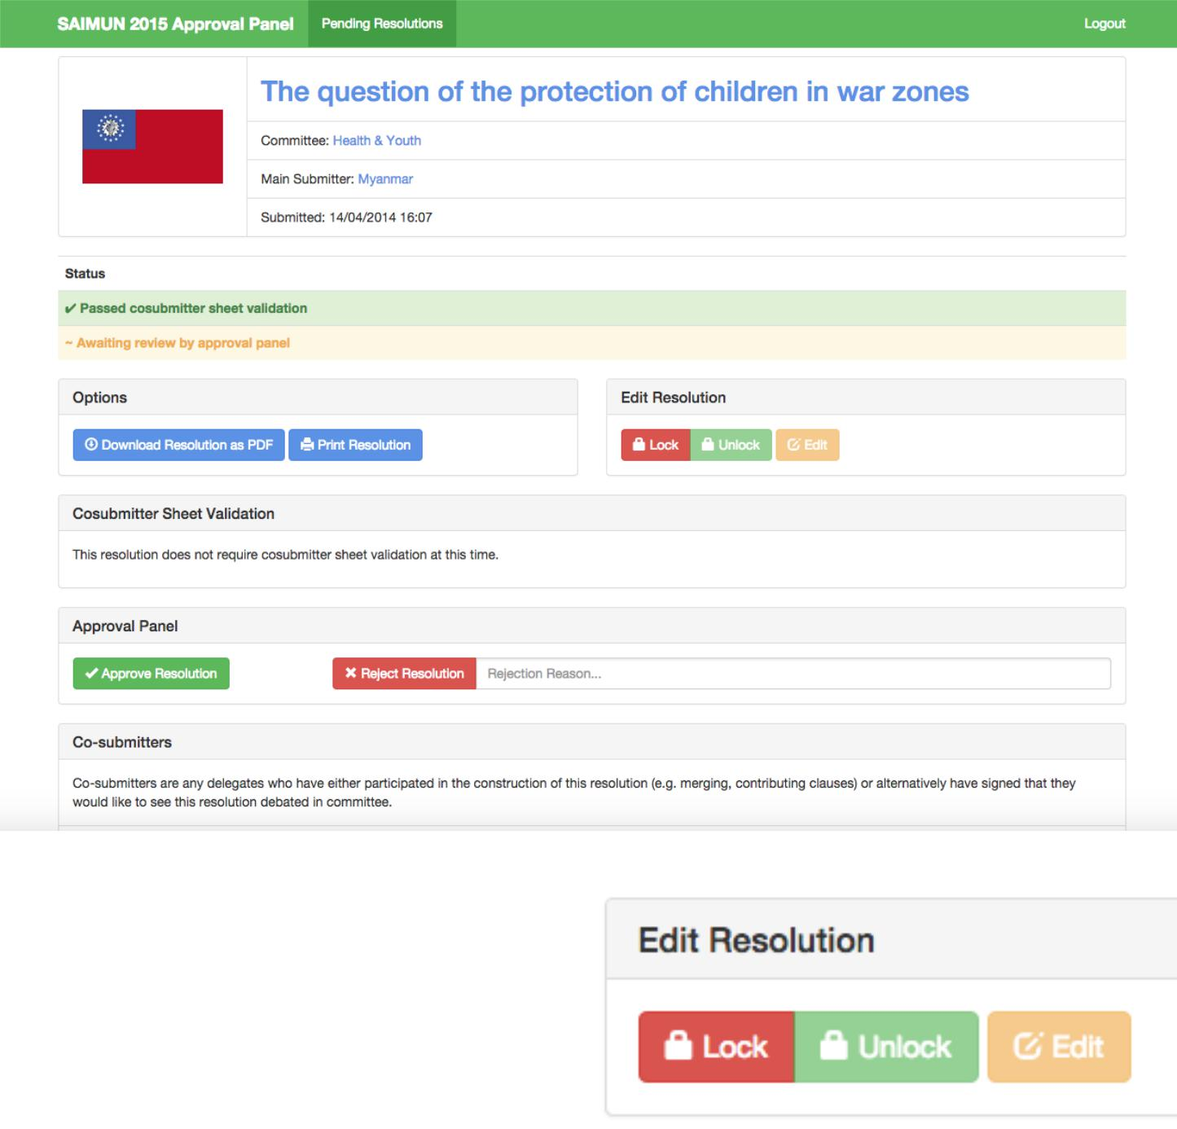

3.3.1 Locking a Resolution

To begin editing the resolution or approve/reject it you must first obtain a lock on it by clicking the Lock button.

Once you have locked a resolution no one else will be able to process it until either you or the Head of IT unlocks it. This prevents two members of Approval Panel from accidentally interfering with each other.
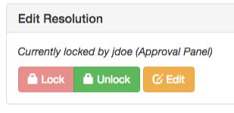
Your name will be listed as having locked the resolution and you will then be able to click the Edit button.
3.3.2 Editing a Resolution

Simply click the Edit button to begin editing the resolution, the below screen will appear:
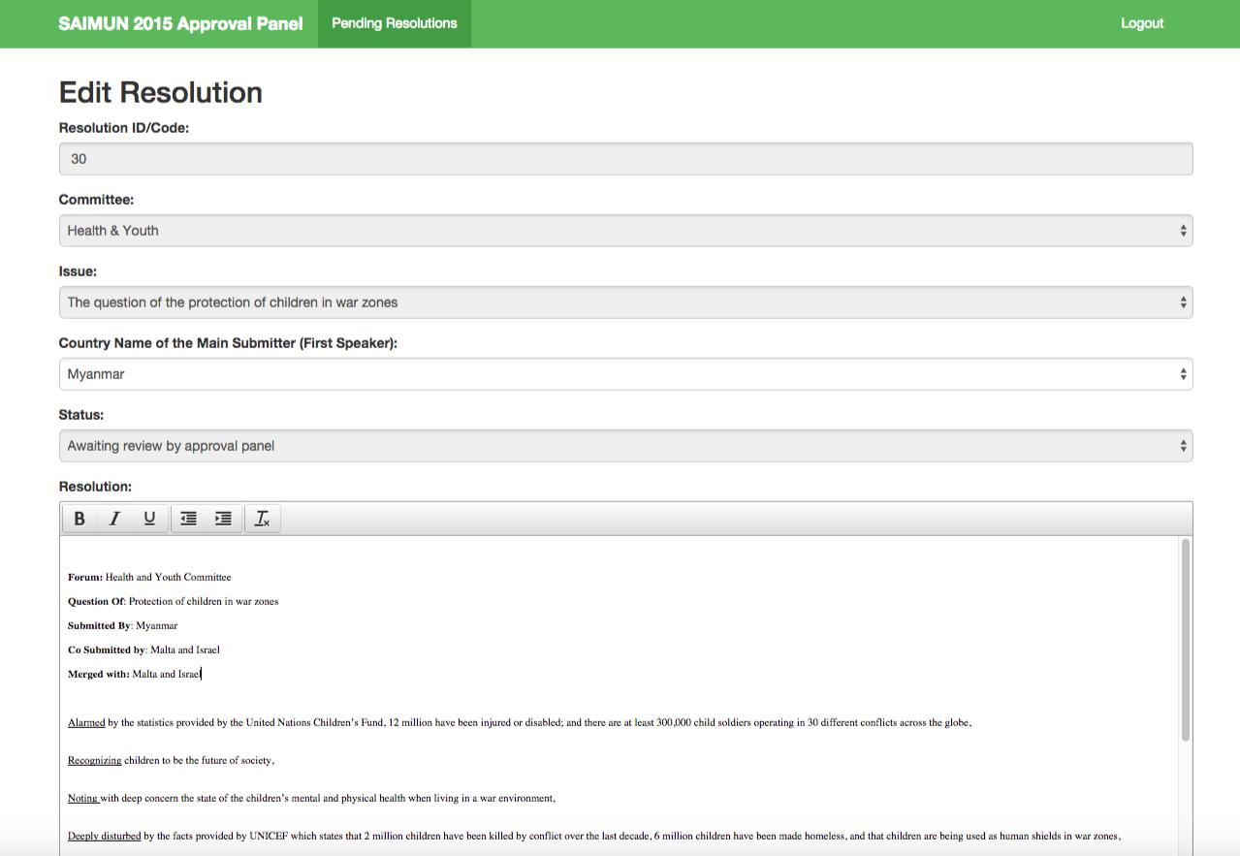

From this screen you can change the country name of the main submitter and the resolution’s content

If you need to change other information such as the committee or issue you should ask the member of SAIMUN staff in charge of approval panel to do this.

3.3.3 Working with Drafts
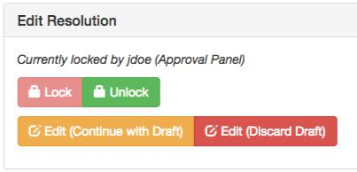
If you begin to alter the content of a resolution it will be automatically saved as a Draft every minute. If you accidentally navigate away from the resolution edit screen, don’t worry! Your work has not been lost. When you go back to the resolution you will see two options, you can choose to either continue editing where you left off or to discard your work and start from scratch.
3.3.4 Approving/Rejecting a Resolution
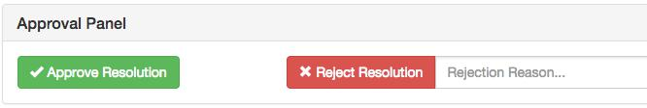

First of all, ensure you have obtained a lock on the resolution, otherwise your attempt to approve/ reject the resolution will fail. If you forget, don’t panic! Just obtain a lock and then try again.

If you are approving the resolution please simply click Approve Resolution.

If you wish to reject it you must first enter a reason. This reason will be public and the delegate who submitted the resolution will likely see it so please enter something useful for them. Then just click the Reject Resolution button.

Once a resolution is approved/rejected it will disappear from the approval panel overview and you will no longer be able to perform actions on it.

Please remember to unlock the resolution after you approve/reject it.

